# VISVESVARAYATECHNOLOGICALUNIVERSITY

**“JnanaSangama”, Belgaum -590014, Karnataka.**



**LAB REPORT on**

**Database Management Systems (23CS3PCDBM)**

***Submitted by***

**CHITRASHREE K (1BM23CS081)**

***in partial fulfilment for the award of the degree of***

## BACHELOR OF ENGINEERING

***in***

**COMPUTER SCIENCE AND ENGINEERING**



**B.M.S. COLLEGE OF ENGINEERING**

**(Autonomous Institution under VTU)**

**BENGALURU-560019**

**December-2023 to Feb-2024**

**B. M. S. College of Engineering,**

**Bull Temple Road, Bangalore 560019**

(Affiliated To Visvesvaraya Technological University, Belgaum)

**Department of Computer Science and Engineering**



### CERTIFICATE

This is to certify that the Lab work entitled “Database Management Systems (22CS3PCDBM)” carried out by **CHITRASHREE K (1BM23CS081),** who is a bonafide student of **B. M. S. College of Engineering.** It is in partial fulfilment for the award of **Bachelor of Engineering in Computer** **Science and Engineering** of the Visveshwaraiah Technological University, Belgaum during the year 2024. The Lab report has been approved as it satisfies the academic requirements in respect of a Database Management Systems (23CS3PCDBM) work prescribed for the said degree.

|  |  |
| --- | --- |
| Sheetal V A  Associate Professor  Department of CSE, BMSCE | Dr. Kavitha Sooda  Professor HOD  Department of CSE, BMSCE |

`

# Index

|  |  |  |  |
| --- | --- | --- | --- |
| **Sl.**  **No.** | **Date** | **Experiment Title** | **Page No.** |
| 1 | 04-10-2024 | Insurance Database | 1-8 |
| 2 | 11-10-2024 | More Queries on Insurance Database | 9-10 |
| 3 | 18-10-2024 | Bank Database | 11-19 |
| 4 | 25-10-2024 | More Queries on Bank Database | 20-22 |
| 5 | 08-11-2024 | Employee Database | 23-31 |
| 6 | 15-11-2024 | More Queries on Employee Database | 32-36 |
| 7 | 15-12-2024 | Supplier Database | 37-45 |
| 8 | 20-12-2024 | NoSQL Lab 1 | 46-49 |
| 9 | 20-12-2024 | NoSQL Lab 2 | 50-51 |
| 10 | 20-12-2024 | NoSQL Lab 3 | 52-55 |

## Insurance Database

**Question**

### (Week 1)

* PERSON (driver_id: String, name: String, address: String)
* CAR (reg_num: String, model: String, year: int)
* ACCIDENT (report_num: int, accident_date: date, location: String)
* OWNS (driver_id: String, reg_num: String)
* PARTICIPATED (driver_id: String,reg_num: String, report_num: int, damage_amount: int)
* Create the above tables by properly specifying the primary keys and the foreign keys. **-**

Enter at least five tuples for each relation

* Display Accident date and location
* Update the damage amount to 25000 for the car with a specific reg_num (example 'K A031181' ) for which the accident report number was 12.
* Add a new accident to the database.
* To Do
* Display Accident date and location
* Display driver_id who did accident with damage amount greater than or equal to

Rs.25000

### Schema Diagram

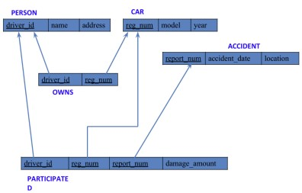

### Create database

### create database insurance_1BM23CS081;

### use insurance_1BM23CS081;

### Create table

create table PERSON_081(

driver_id varchar(20),

name varchar(30),

address varchar(100),

primary key (driver_id));

create table CAR_081(

reg_num varchar(20),

model varchar (10),

year int,

Primary key (req_num));

create table ACCIDENT_081(

report_num int,

accident_date date,

location varchar (100),

primary key (report_num));

create table OWNS_081(

driver_id varchar(20),

reg_num varchar(20),

primary key (driver_id, reg_num),

foreign key (driver_id) references PERSON_081 (driver_id),

foreign key (reg_num) references CAR_081(reg_num));

create table PARTICIPATED_081(

driver_id varchar (20),

reg_num varchar(20),

report_num int,

damage_amount int,

primary key (driver_id, reg_num, report_num),

foreign key (driver_id) references PERSON_081 (driver_id),

foreign key (reg_num) references CAR_081 (reg_num),

foreign key (report_num) references ACCIDENT_081 (report_num));

### Structure of the table

PERSON_081

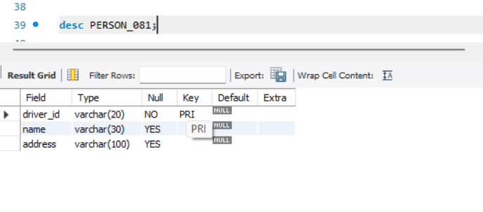

ACCIDENT_081

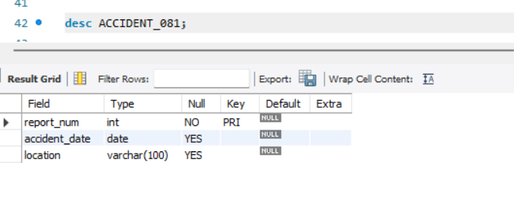

PARTICIPATED_081

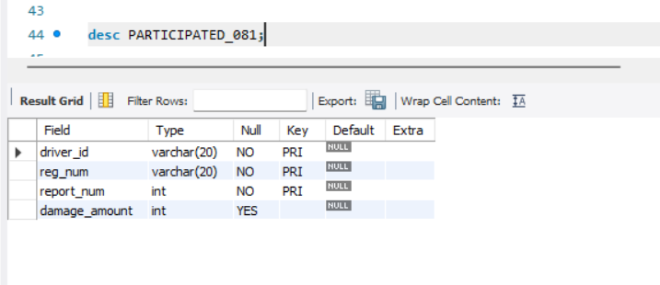

CAR_081

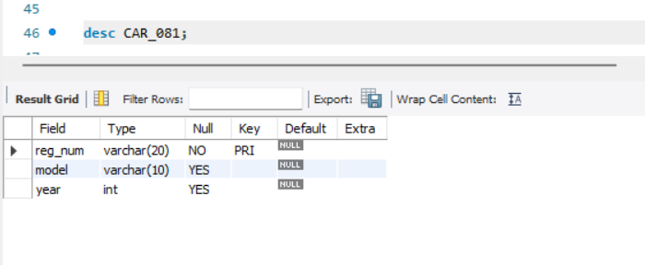

OWNS_081

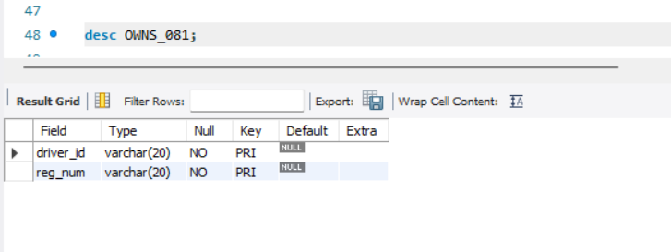

### Inserting Values into the table

insert into PERSON_081 values

("A01", "Richard", "Sri Nagar"),

("A02", "Pradeep", "Raj Nagar"),

("A03", "Smith", "Ashok Nagar"),

("A04", "Venu", "N R Colony"),

("A05", "John", "Hanu Nagar");

insert into CAR_081 values

("KA052250", "Indica", 1990),

("KA031181", "Lancer", 1957),

("KA095477", "Toyota", 1998),

("KA053408", "Honda", 2008),

("KA041702", "Audi", 2005);

insert into OWNS_081 values

("A01", "KA052250"),

("A02", "KA031181"),

("A03", "KA095477"),

("A04", "KA053408"),

("A05", "KA041702");

insert into ACCIDENT_081 values

(11, "01-01-03", "Mysore Rd"),

(12, "02-02-04", "SE Circle"),

(13, "21-01-03", "Bull Temple Rd"),

(14, "17-02-08", "Mysore Rd"),

(15, "04-03-05", "KR Puram");

insert into PARTICIPATED_081 values

("A01", "KA052250", 11, 10000),

("A02", "KA031181", 12, 50000),

("A03", "KA053408", 13, 25000),

("A04", "KA095477", 14, 3000),

("A05", "KA041702", 15, 5000);

**INSERTED VALUES**

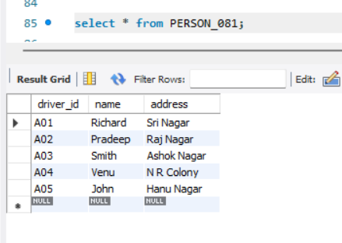

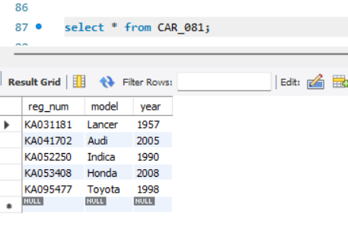

### 

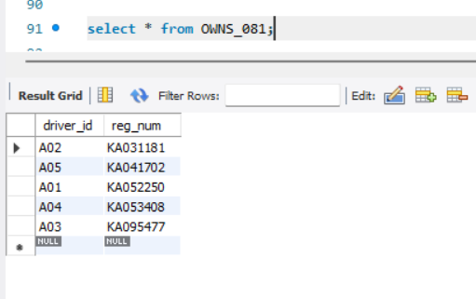

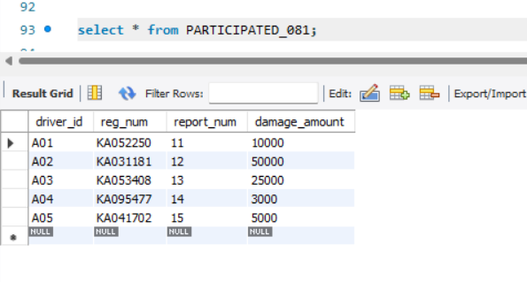

### Queries

**1. Update the damage amount to 25000 for the car with a specific reg-num (example 'KA031181' ) for which the accident report number was 12.**

Query : update PARTICIPATED_081 set damage_amount = 25000 where reg_num = "KA031181" and report_num = 12;

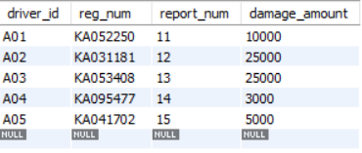

**2.** **Display Accident date and location**

Query : select accident_date, location from ACCIDENT_081;

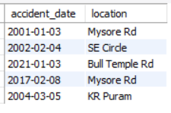

**3.Add a new accident to the database.**

Query : insert into ACCIDENT_081

values (16, "01-01-10", "BTM");

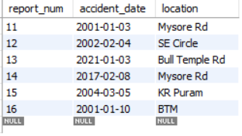

**4.Display driver id who did the accident damage greater than or equal to Rs.25000**

Query : select driver_id

from PARTICIPATED_081

where damage_amount >=25000;

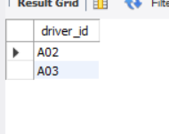

### More Queries On Insurance Database

### (Week 2)

**1.List The Entire Participated Relation In The Descending Order Of Damage Amount.**

**Query :** select * from PARTICIPATED_081 order by damage_amount desc;

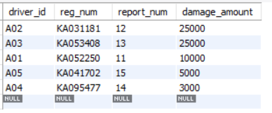

**2.** **Find The Average Damage Amount**

Query : select avg(damage_amount) from PARTICIPATED_081;

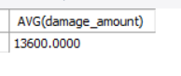

**3.List The Name Of Driver Whose Damage Is Greater Than The Average Damage Amount.**

Query : select name from PERSON_081, PARTICIPATED_081 where PERSON_081.driver_id = PARTICIPATED_081.driver_id and PARTICIPATED_081.damage_amount > (select avg(damage_amount) from PARTICIPATED_081);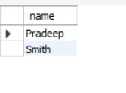

## Bank Database

**Question**

### (Week 3)

* Branch (branch-name: String, branch-city: String, assets: real)
* BankAccount(accno: int, branch-name: String, balance: real)
* BankCustomer (customer-name: String, customer-street: String, customer-city: String) **-**

Depositer(customer-name: String, accno: int)

* LOAN (loan-number: int, branch-name: String, amount: real)
* Create the above tables by properly specifying the primary keys and the foreign keys. Enter at least five tuples for each relation.
* Display the branch name and assets from all branches in lakhs of rupees and rename the assets column to 'assets in lakhs'.
* Find all the customers who have at least two accounts at the same branch (ex. SBI_ResidencyRoad).
* Create a viewwhich gives each branch the sum of the amount of all the loans at the branch.

### Schema Diagram

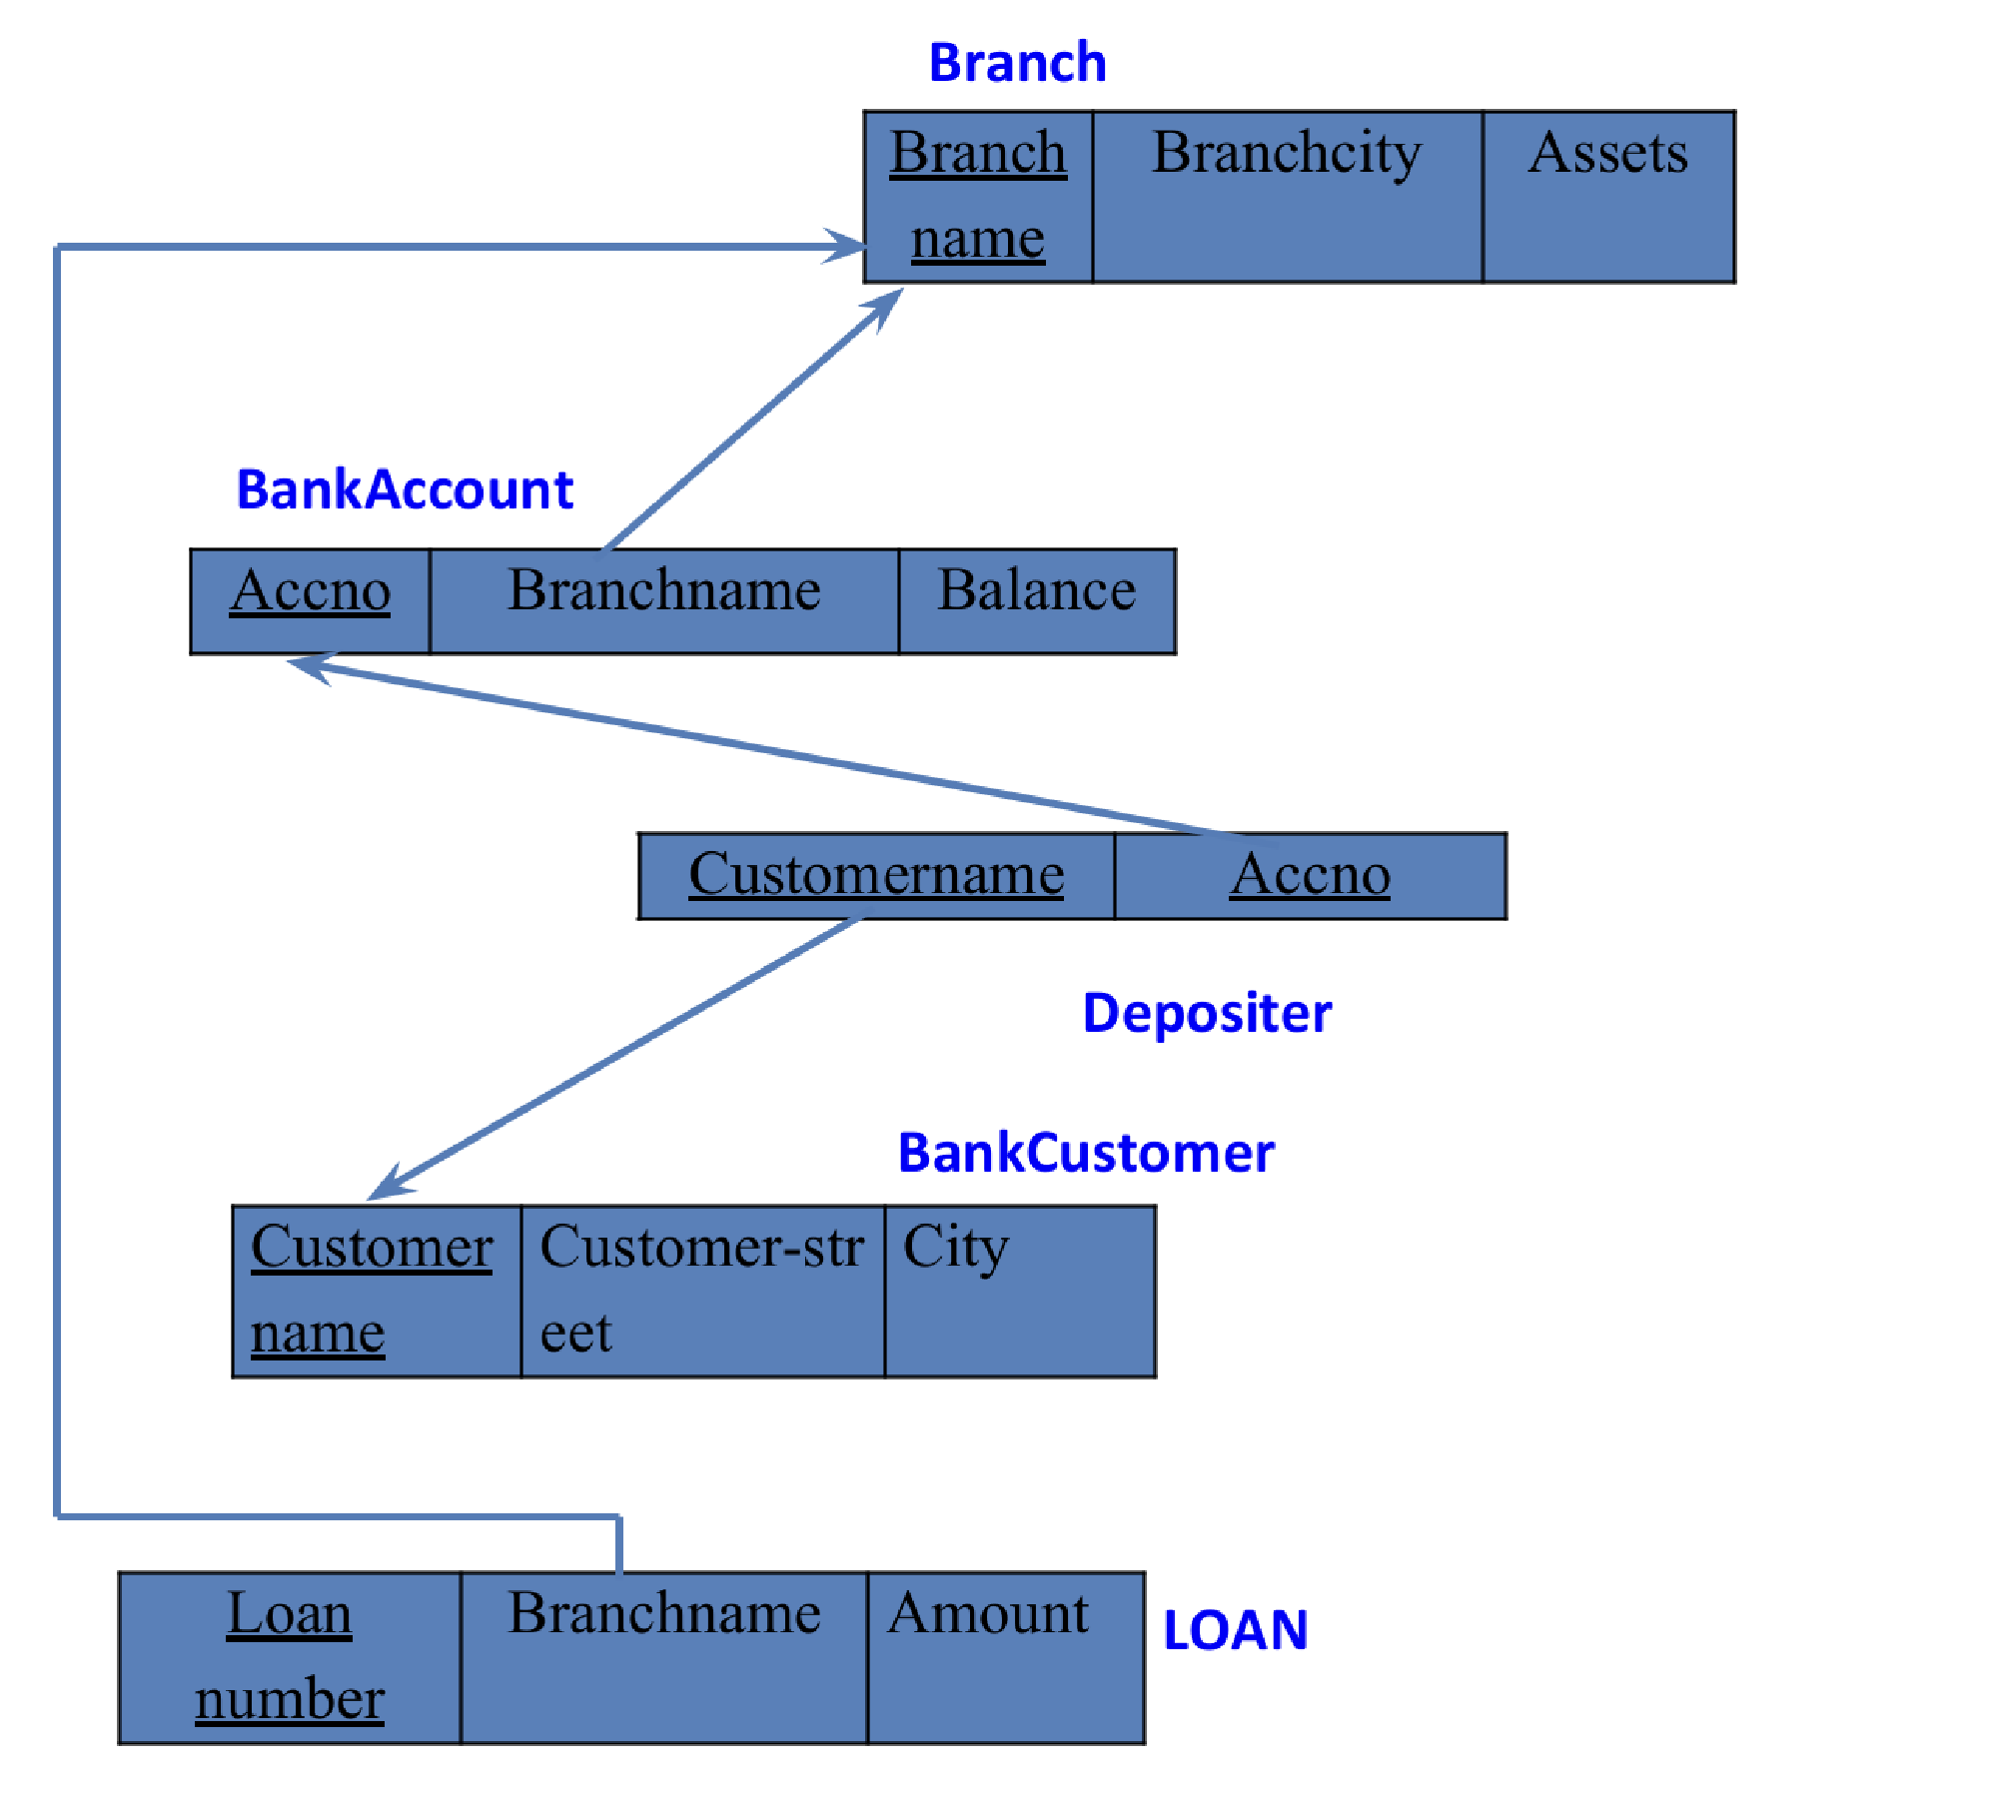

### Create database

### create database bank_database_1BM23CS081;

### use bank_database_1BM23CS081;

### Create table

### create table BRANCH_081(

### branch_name varchar(100),

### branch_city varchar(100),

### assets real,

### primary key (branch_name));

### create table BANK_ACCOUNT_081(

### acc_no int,

### branch_name varchar(100),

### balance real,

### primary key(acc_no),

### foreign key(branch_name) references BRANCH_081(branch_name));

### create table BANK_CUSTOMER_081(

### customer_name varchar(100),

### customer_street varchar(100),

### customer_city varchar(100),

### primary key(customer_name));

### create table DEPOSITOR_081(

### customer_name varchar(100),

### acc_no int,

### primary key(customer_name, acc_no),

### foreign key(acc_no) references BANK_ACCOUNT_081(acc_no),

### foreign key(customer_name) references BANK_CUSTOMER_081(customer_name));

### create table LOAN_081(

### loan_number int,

### branch_name varchar(100),

### amount real,

### primary key(loan_number),

### foreign key(branch_name) references BRANCH_081(branch_name));

### Structure of the table

BRANCH_081

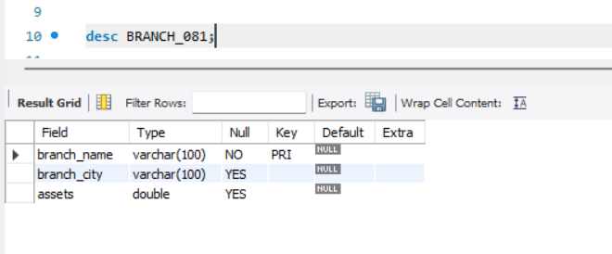

BANK_ACCOUNT_081

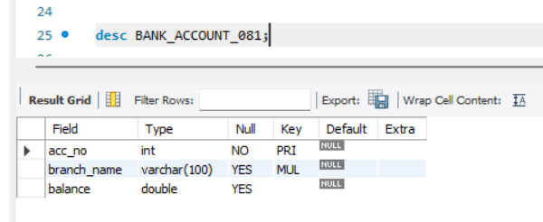

### BANK_CUSTOMER_081

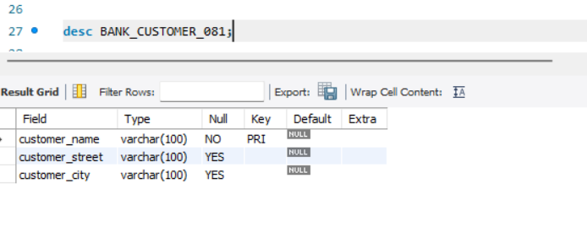DEPOSITOR_081

### 

LOAN_081

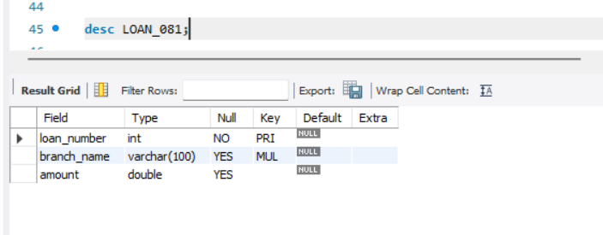

### Inserting Values to the table

insert into BRANCH_081(branch_name, branch_city, assets)

values ("SBI_Chamrajpet", "Bangalore", 50000),

("SBI_ResidencyRoad", "Bangalore", 10000),

("SBI_Shivaginagar", "Bombay", 20000),

("SBI_ParlimentRoad", "Delhi", 10000),

("SBI_Jantarmantar", "Delhi", 20000);

insert into BANK_ACCOUNT_081(acc_no, branch_name, balance)

values (1, "SBI_Chamrajpet", 2000),

(2, "SBI_ResidencyRoad", 5000),

(3, "SBI_Shivaginagar", 6000),

(4, "SBI_ParlimentRoad", 9000),

(5, "SBI_Jantarmantar", 8000),

(6, "SBI_Shivaginagar", 4000),

(8, "SBI_ResidencyRoad", 4000),

(9, "SBI_ParlimentRoad", 3000),

(10, "SBI_ResidencyRoad", 5000),

(11, "SBI_Jantarmantar", 2000);

insert into BANK_CUSTOMER_081(customer_name, customer_street,customer_city)

values ("Avinash", "Bull Temple Road", "Bangalore"),

("Dinesh", "Bannergatta Road", "Bangalore"),

("Mohan", "National College Road", "Bangalore"),

("Nikil", "Akbar Road", "Delhi"),

("Ravi", "Prithiviraj Road", "Delhi");

insert into DEPOSITOR_081(customer_name, acc_no)

values ("Avinash", 1),

("Dinesh", 2),

("Nikil", 4),

("Ravi", 5),

("Avinash", 8),

("Nikil", 9),

("Dinesh", 10),

("Nikil", 11);

insert into LOAN_081(loan_number, branch_name, amount)

values (1, "SBI_Chamrajpet", 1000),

(2, "SBI_ResidencyRoad", 2000),

(3, "SBI_Shivaginagar", 3000),

(4, "SBI_ParlimentRoad", 4000),

(5, "SBI_Jantarmantar", 5000);

**Inserted Values**

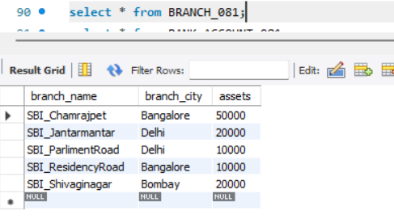

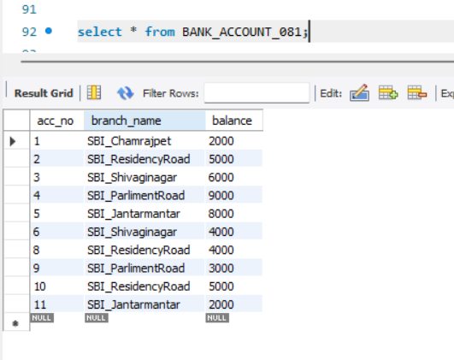

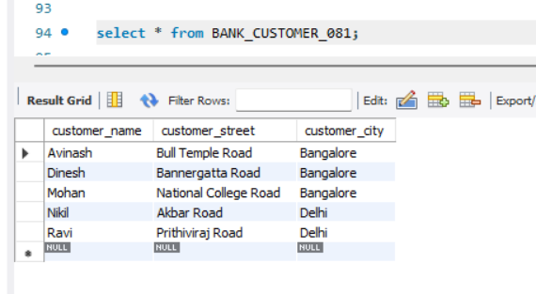

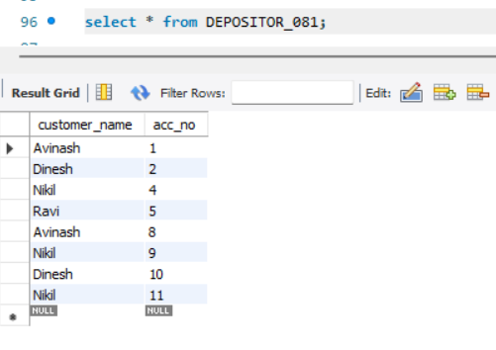

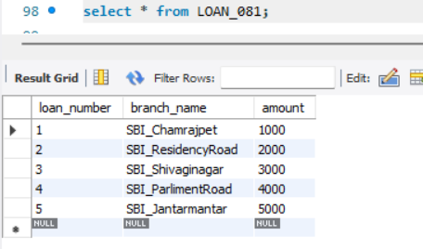

### Queries

**1.Display the branch name and assets from all branches and rename the assets column to 'assets in lakhs'.**

Query : select branch_name, assets/100000 as assetsinlakhs from BRANCH_081;

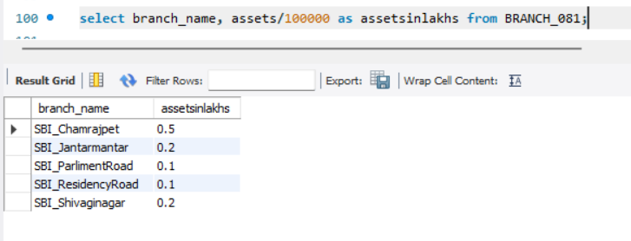

**2.Find all the customers who have at least two accounts at the same branch (ex.SBI_ResidencyRoad).**

Query : select d.customer_name, b.branch_name, count(d.acc_no) as account_no

from DEPOSITOR_081 d, BANK_ACCOUNT_081 b

where d.acc_no=b.acc_no

group by d.customer_name, b.branch_name

having count(d.acc_no)>=2;

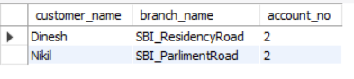

### (Week 4)

### More Queries On Bank Database

**1. Retrieve all branches and their respective total assets**

Query : select branch_name, assets

from BRANCH_081;

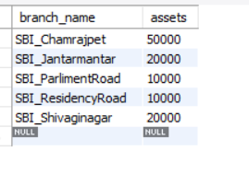

**2. List all customers who live in a particular city**

Query : select customer_name, customer_city

from BANK_CUSTOMER_081;

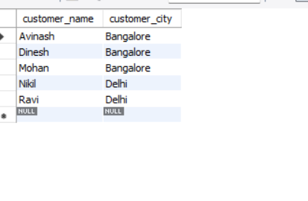

**3. List all customers with their account numbers**

Query : select customer_name, acc_no

from DEPOSITOR_081;

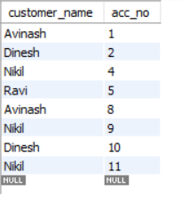

**4. Get the number of accounts held at each branch**

Query : select branch_name, count(acc_no) as total_accounts

from BANK_ACCOUNT_081

GROUP BY branch_name;

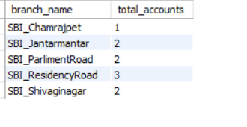

**5. Retrieve the branch with the smallest total loan amount**

Query : select branch_name

from LOAN_081

where amount=(select min(amount) from LOAN_081);

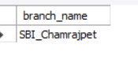

**6. Find all branches that have no loans issued**

Query : select branch_name

from BRANCH_081

where branch_name not in(select branch_name from LOAN_081);

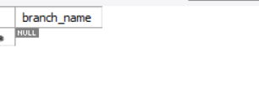

**7.Find all customers who have accounts with a balance greater than a specified amount (100000)**

Query : select d.customer_name

from DEPOSITOR_081 d, BANK_ACCOUNT_081 b

where d.acc_no=b.acc_no and b.balance>5000;

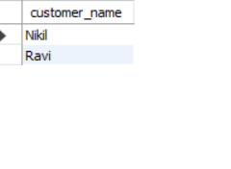

## Employee Database

## (Week 5)

1. Using Scheme diagram, Create tables by properly specifying the primary keys and the foreign keys.
2. Enter greater than five tuples for each table.
3. Retrieve the employee numbers of all employees who work on project located in Bengaluru, Hyderabad, or Mysuru
4. Get Employee ID’s of those employees who didn’t receive incentives
5. Write a SQL query to find the employees name, number, dept, job_role, department location and project location who are working for a project location same as his/her department location.

### Schema Diagram

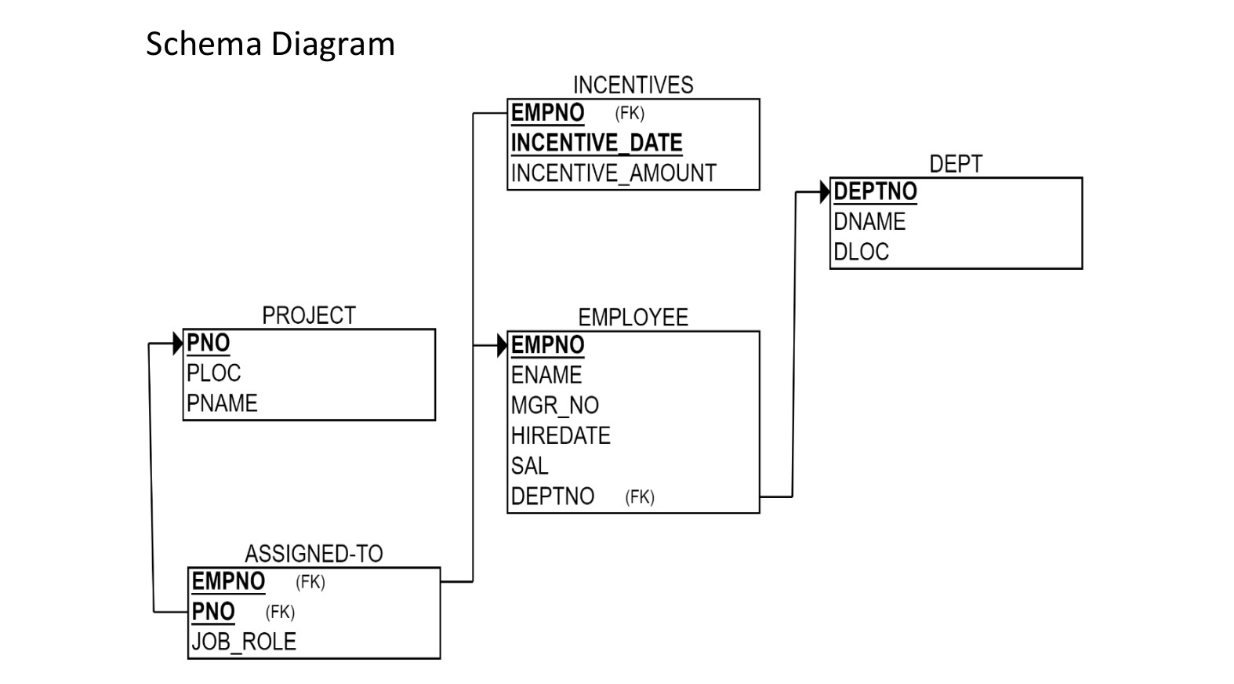

### Create database

### create database employee_1BM23CS081;

### use employee_1BM23CS081;

### Create table

### create table DEPT_081(

### dept_no int ,

### dname varchar(30),

### dloc varchar(55),

### primary key(dept_no));

### create table PROJECT_081(

### pno int ,

### ploc varchar(30),

### pname varchar(55),

### primary key(pno));

### create table EMPLOYEE_081(

### empno int ,

### ename varchar(55),

### mgr_no int,

### hiredate date,

### sal int,

### dept_no int ,

### primary key(empno),

### foreign key(dept_no) references DEPT_081(dept_no));

### create table INCENTIVES_081(

### empno int ,

### incentive_date date,

### incentive_amount int,

### primary key(empno , incentive_date ),

### foreign key(empno) references EMPLOYEE_081(empno));

### create table ASSIGNED_081(

### empno int,

### pno int,

### job_role varchar(55),

### primary key(empno, pno),

### foreign key(empno) references EMPLOYEE_081(empno),

### foreign key(pno) references PROJECT_081(pno));

### Structure of the table

DEPT_081

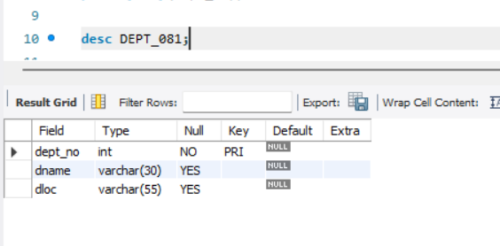

PROJECT_081

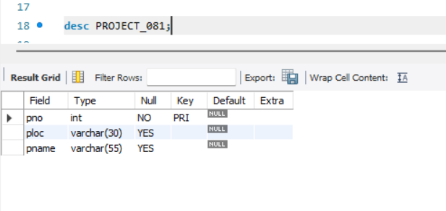

EMPLOYEE_081

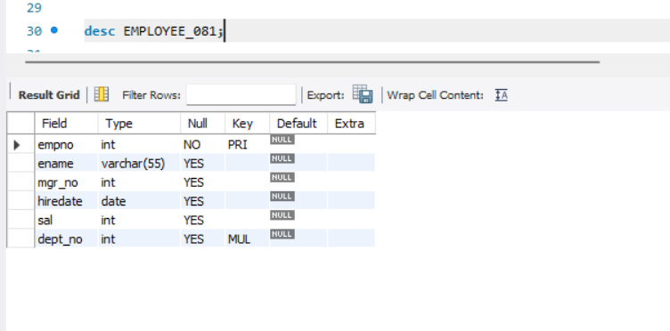

INCENTIVES_081

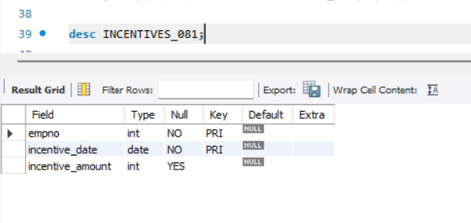

ASSIGNED_081

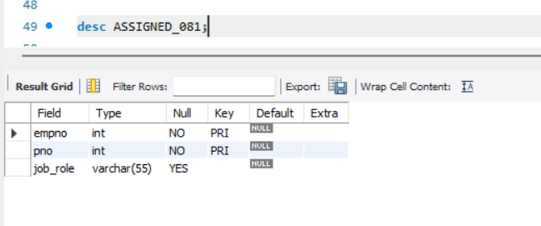

### Inserting Values to the table

insert into DEPT_081(dept_no, dname, dloc)

values (1, "IT", "MUMBAI"),

(2, "AI", "BANGALORE"),

(3, "DATA SCIENCE", "DELHI"),

(4, "ML", "HYDERABAD"),

(5, "ADMINISTRATION", "MYSORE"),

(6, "LEGAL", "MANGALORE");

insert into PROJECT_081(pno, ploc, pname)

values (1, "BANGALORE", "WEB DEV"),

(2, "MYSORE", "APP DEV"),

(3, "DELHI", "NLP"),

(4, "MUMBAI", "AR GAME"),

(5, "HYDERABAD", "IOT AUTOMATION"),

(6, "BANGALORE", "AI CHATBOT"),

(7, "MUMBAI", "CRYPTO CURRENCY"),

(8, "MYSORE", "TRAFFIC MANAGEMENT");

insert into EMPLOYEE_081(empno, ename, mgr_no, hiredate, sal, dept_no)

values (1, "ABAY", 5, '2024-01-15', 48000, 4),

(2, "JOHN", 1, '2023-03-22', 50000, 1),

(3, "DANIEL", 2, '2022-06-10', 82000, 5),

(4, "DAVID", 8, '2023-09-30', 95000, 6),

(5, "JAMES", 1, '2020-12-05', 55000, 2),

(6, "THOMAS", 5, '2017-11-01', 65000, 1),

(7, "ROBERT", 8, '2019-04-18', 75000, 5),

(8, "LAURA", 2, '2018-08-25', 80000, 3);

insert into INCENTIVES_081(empno, incentive_date, incentive_amount)

values (4, '2024-05-20', 1800),

(3, '2024-06-30', 2500),

(8,'2024-09-18', 1700),

(7, '2024-03-15', 2200),

(1, '2024-02-01', 1950);

insert into ASSIGNED_081(empno, pno, job_role)

values (6, 8, "MANAGER"),

(1, 3, "AI RESEACHER"),

(3, 2, "APP DEVELOPER"),

(5, 5, "DEVOPS ENGINEER"),

(2, 4, "GAME DEVELOPER"),

(7, 1, "WEB DEVELOPER"),

(4, 7, "ANALYST"),

(8, 6, "AIML ENGINEER");

**Inserted Values**

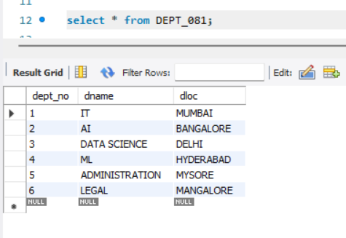

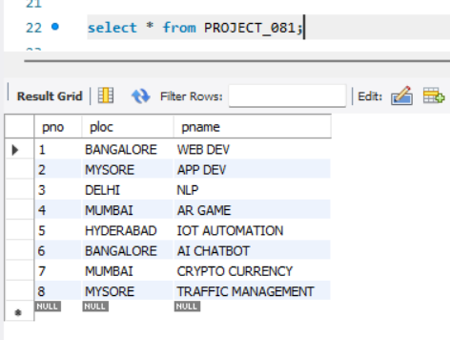

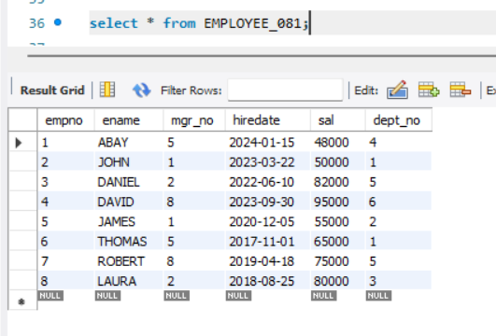

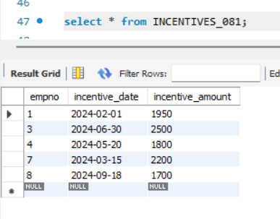

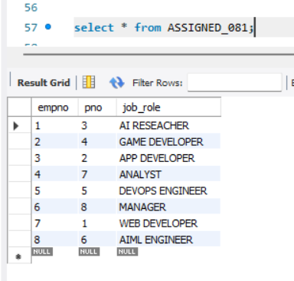

**Queries**

**1.Retrieve the employee numbers of all employees who work on project located in Bengaluru, Hyderabad, or Mysuru.**

**Query :** select ASSIGNED_081.empno from ASSIGNED_081, PROJECT_081 where ASSIGNED_081.pno = PROJECT_081.pno and PROJECT_081.ploc in ("Bengaluru", "Mysuru", "Hyderabad");

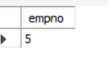

**2.Get Employee ID’s of those employees who didn’t receive incentives** Query : select empno from employee_204 where empno not in (select empno from incentives_204);

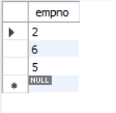

**3.Write a SQL query to find the employees name, number, dept, job_role, department location and project location who are working for a project location same as his/her department location.**

Query : select e.ename, e.empno, d.dept_no, a.job_role, d.dloc, p.ploc

from EMPLOYEE_081 e, DEPT_081 d, ASSIGNED_081 a, PROJECT_081 p

where e.dept_no=d.dept_no and a.empno=e.empno and a.pno=p.pno and p.ploc=d.dloc;

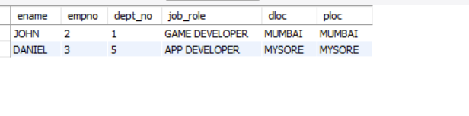

### (Week 6)

**More Queries on Employee Database**

### Queries

**1.** **List all employees along with their project details (if assigned)**

Query : select e.ename, p.pname

from ASSIGNED_081 a, EMPLOYEE_081 e, PROJECT_081 p

where a.empno=e.empno and a.pno=p.pno;

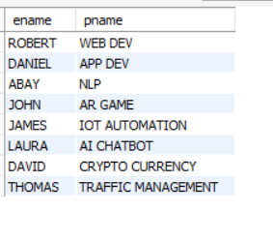

**2.** **Find all employees who received incentives, along with the total incentive amount**

Query : select e.ename , i.incentive_amount as total_incentive from EMPLOYEE_081 e, INCENTIVES_081 i where e.empno=i.empno;

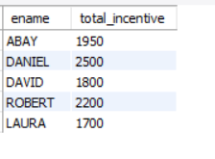

**3.List departments along with the number of employees in each department2019.**

Query : select d.dname, count(e.ename) as no_of_employee

from DEPT_081 d, EMPLOYEE_081 e

where d.dept_no=e.dept_no

group by e.dept_no;

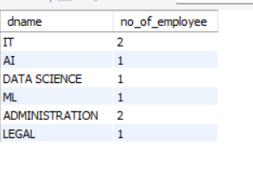

**4.** **Find employees who have not been assigned to any project**

Query : select e.empno

from EMPLOYEE_081 e

where e.empno not in(select a.empno from ASSIGNED_081 a);

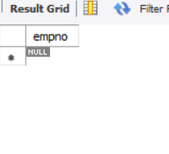

**5.List all employees along with their department names and location**

Query : select e.ename, d.dname, d.dloc

from EMPLOYEE_081 e, DEPT_081 d

where e.dept_no=d.dept_no;

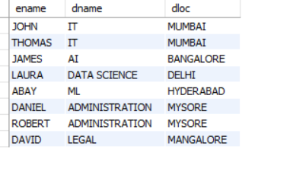

**6.Retrieve the details of employees who work under a specific manager (e.g., manager with empno = 5)**

Query : select ename, mgr_no, hiredate, sal, dept_no

from EMPLOYEE_081

where mgr_no=5;

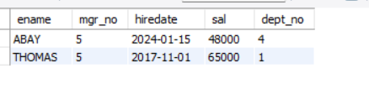

**7.List all projects that have employees assigned and the number of employees on each project:**

Query : select p.pname, count(a.empno) as no_of_employee

from ASSIGNED_081 a, PROJECT_081 p

where a.pno=p.pno

group by p.pname;

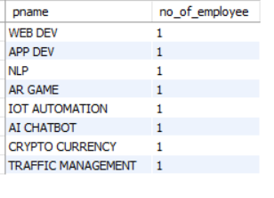

**8.** **Find employees with the same manager and list their department details**

Query : select e1.empno, e1.ename, d.dept_no, d.dname, d.dloc

from EMPLOYEE_081 e1

join EMPLOYEE_081 e2 on e1.mgr_no=e2.mgr_no and e1.empno<> e2.empno

join DEPT_081 d on e1.dept_no=d.dept_no;

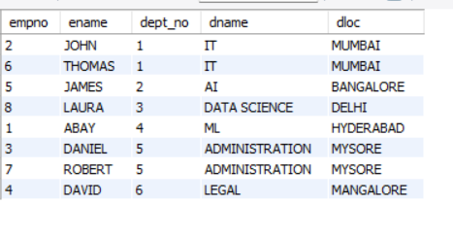

**9. Retrieve all employees who have the role of 'Developer' on any project:**

Query : select e.ename

from EMPLOYEE_081 e, ASSIGNED_081 a

where a.empno=e.empno and a.job_role like "%DEVELOPER";

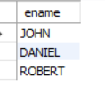

**10.** **Display the department-wise average salary of employees:**

Query : select avg(e.sal)

from EMPLOYEE_081 e, DEPT_081 d

where e.dept_no=d.dept_no

group by e.dept_no;

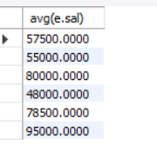

**SUPPLIER DATABASE**

**Question**

**(Week 7)**

1. Using Scheme diagram, Create tables by properly specifying the primary keys and the foreign keys.

2. Insert appropriate records in each table.

3. Find the pnames of parts for which there is some supplier.

4. Find the snames of suppliers who supply every part.

5. Find the snames of suppliers who supply every red part.

6. Find the pnames of parts supplied by Acme Widget Suppliers and by no one else.

7. Find the sids of suppliers who charge more for some part than the average cost of that part (averaged over all the suppliers who supply that part).

8. For each part, find the sname of the supplier who charges the most for that part.

**Schema Diagram**

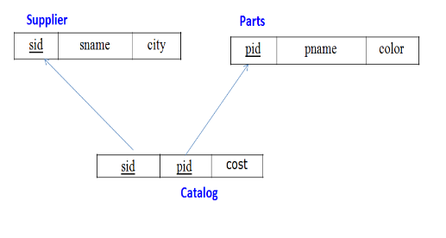

**Create Database**

create database supplier_database_142;

use supplier_database_142;

**Create Tables**

create table suppliers(

sid int,

sname varchar(100),

city varchar(100),

primary key(sid));

create table parts(

pid int,

pname varchar(100),

color varchar(100),

primary key(pid));

create table catalog(

sid int,

pid int,

cost int,

primary key(sid,pid),

foreign key (pid) references parts(pid),

foreign key (sid) references suppliers(sid)

on delete cascade on update cascade);

**Structure Of The Table**

Desc suppliers;

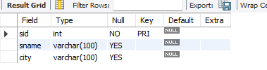

Desc parts;

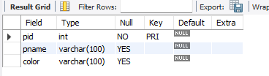

Desc catalog;

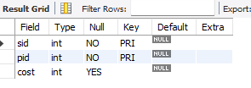

**Inserting Of Values**

insert into suppliers values(

10001,

'Acme widget',

'Bangalore');

insert into suppliers values(

10002,

'Johns',

'Kolkata');

insert into suppliers values(

10003,

'Vimal',

'Mumbai');

insert into suppliers values(

10004,

'Reliance',

'Delhi');

select * from suppliers;

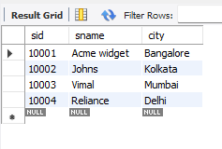

insert into parts values(

20001,

'Book',

'Red');

insert into parts values(

20002,

'Pen',

'Red');

insert into parts values(

20003,

'Pencil',

'Green');

insert into parts values(

20004,

'Mobil',

'Green');

insert into parts values(

20005,

'Charger',

'Black');

select * from parts;

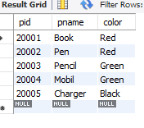

insert into catalog values(

10001,

20001,

10);

insert into catalog values(

10001,

20002,

10);

insert into catalog values(

10001,

20003,

30);

insert into catalog values(

10001,

20004,

10);

insert into catalog values(

10001,

20005,

10);

insert into catalog values(

10002,

20001,

10);

insert into catalog values(

10002,

20002,

20);

insert into catalog values(

10003,

20003,

30);

insert into catalog values(

10004,

20003,

40);

select * from catalog;

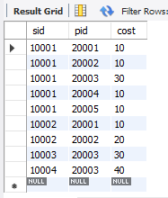

**More Queries On Suppliers Database**

**1. Find the pnames of parts for which there is some supplier.**

select distinct p.pname from parts p join catalog c on p.pid = c.pid;

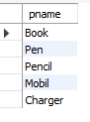

**2. Find the snames of suppliers who supply every part.**

select sname from suppliers s where not exists( select p.pid from parts p where not exists(select c.pid from catalog c where c.pid = p.pid and c.sid = s.sid));

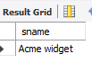

**3. Find the snames of suppliers who supply every red part.**

select sname from suppliers s where not exists(select p.pid from parts p where p.color = 'Red' and not exists(select c.pid from catalog c where c.pid = p.pid and c.sid = s.sid));

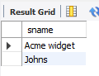

**4. Find the pnames of parts supplied by Acme Widget Suppliers and by no one else.**

select p.pname from parts p join catalog c on p.pid = c.pid join suppliers s on c.sid = s.sid where s.sname = 'Acme widget'and p.pid not in (select c1.pid from catalog c1 where c1.sid <>

(select sid from suppliers where sname = 'Acme widget'));

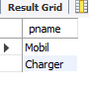

**5. Find the sids of suppliers who charge more for some part than the average cost of that part (averaged over all the suppliers who supply that part).**

select c.sid from catalog c join (select pid,avg(cost) as avg_cost from catalog group by pid) avg_cost_table on c.pid = avg_cost_table.pid where c.cost > avg_cost_table.avg_cost;

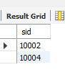

**6. For each part, find the sname of the supplier who charges the most for that part.**

select p.pid,s.sname from parts p join catalog c on p.pid = c.pid join suppliers s on c.sid = s.sid where (c.pid,c.cost) in (select pid,max(cost) from catalog group by pid);

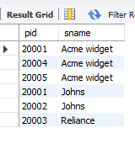

## NoSQL Lab 1

**Question**

### (Week 8)

Perform the following DB operations using MongoDB.

1. Create a database “Student” with the following attributes Rollno, Age, ContactNo, Email-Id.
2. Insert appropriate values
3. Write query to update Email-Id of a student with rollno 10.
4. Replace the student name from “ABC” to “FEM” of rollno 11.
5. Export the created table into local file system
6. Drop the table
7. Import a given csv dataset from local file system into mongodb collection.

**1. Create a database “Student” with the following attributes Rollno, Age, ContactNo, Email-Id.**

db.createCollection("Student");

show dbs

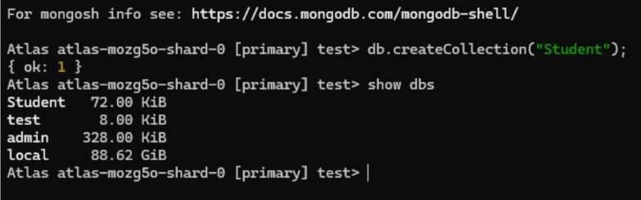

**2. Insert appropriate values**

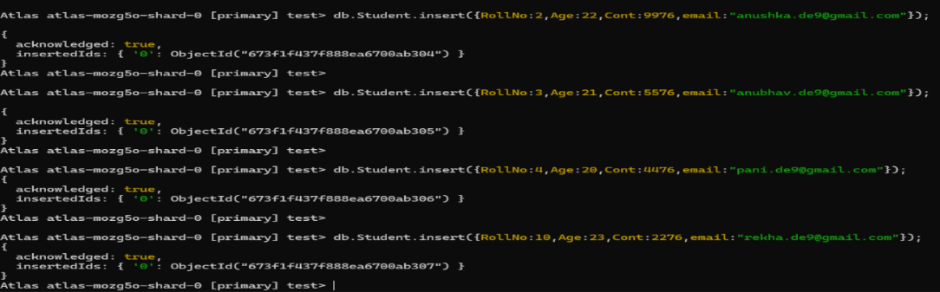

**3. Write a query to update Email-Id of a student with rollno 10.**

db.Student.find()

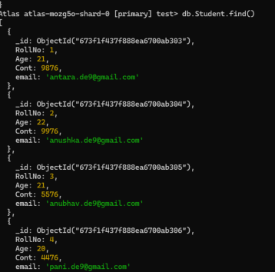

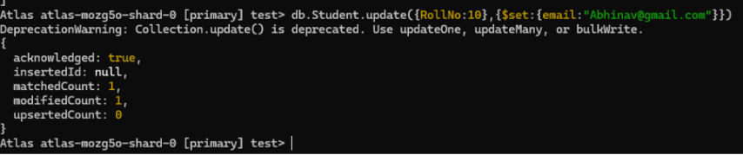

**4. Replace the student name from “ABC” to “FEM” of rollno 11.**

Insert appropriate data:

db.Student.insert({RollNo:11,Age:22,Name:

"ABC",Cont:2276,email:"[rea.de9@gmail.com](mailto:rea.de9@gmail.com)"});

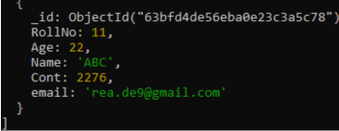

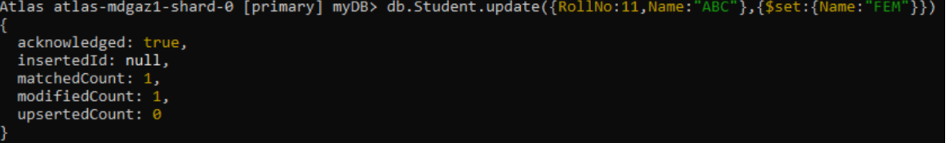

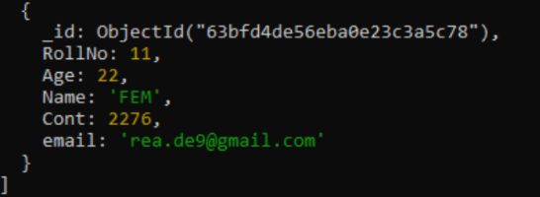

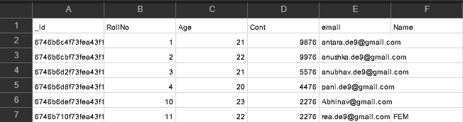

**NoSQL- Customer Database**

(**Week 9)**

**1. Create a collection by name Customers with the following attributes.**

Cust_id, Acc_Bal, Acc_Type and Insert at least 5 values into the table

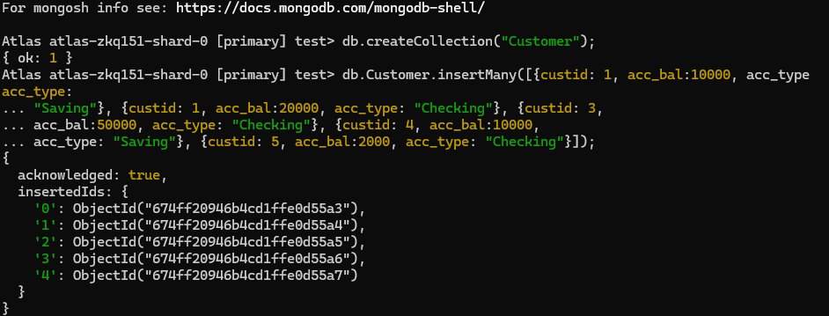

**2. Write a query to display those records whose total account balance is greater than**

12000 of account type ‘Z’ for each customer_id.

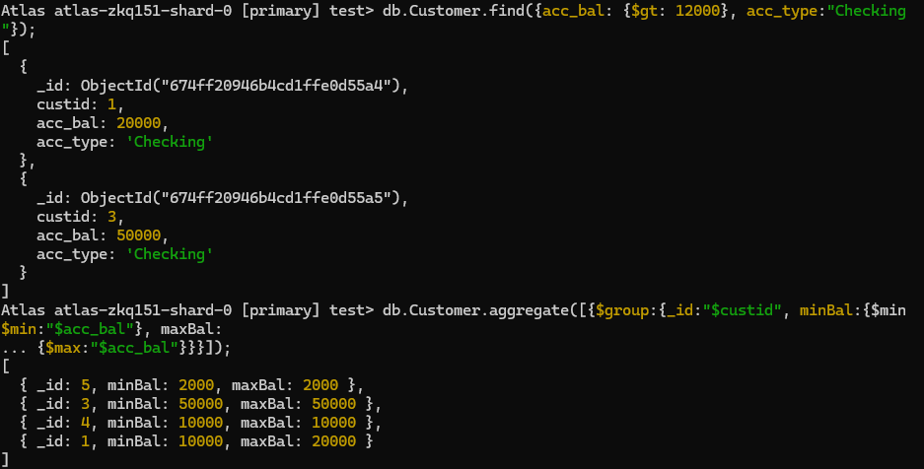

**3. Determine Minimum and Maximum account balance for each customer_id.**



**4. Export the created collection into local file system**

**5. Drop the table**



**6. Import a given csv dataset from local file system into mongodb collection.**

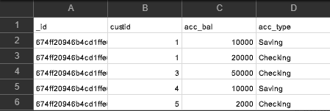

**NoSQL Restaurants Database**

(**Week-10)**

**1.In MongoDB create a collection for “Restaurant” and insert atleast five records**



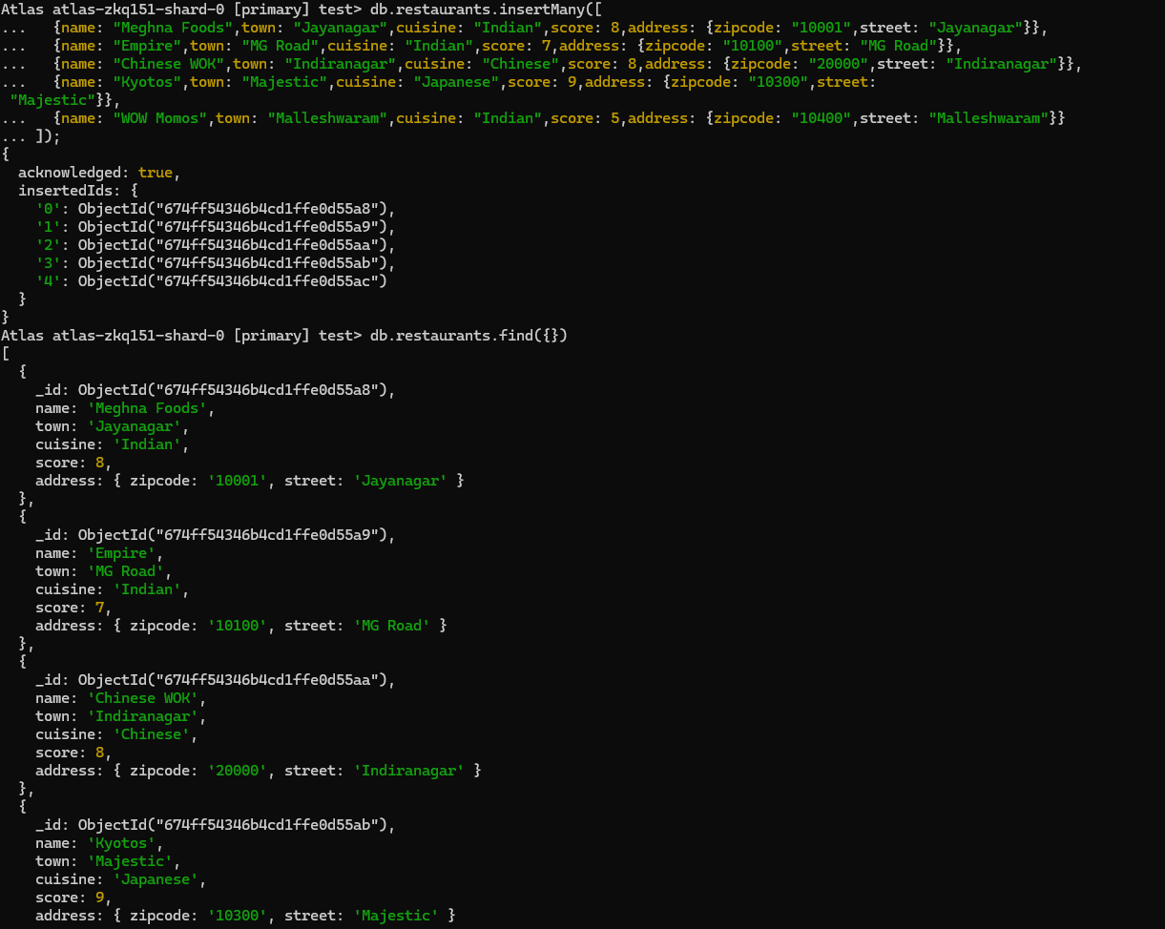

**2. Write a MongoDB query to display all the documents in the collection restaurants.**



**3.Write a MongoDB query to arrange the name of the restaurants in descending along with all the columns.**

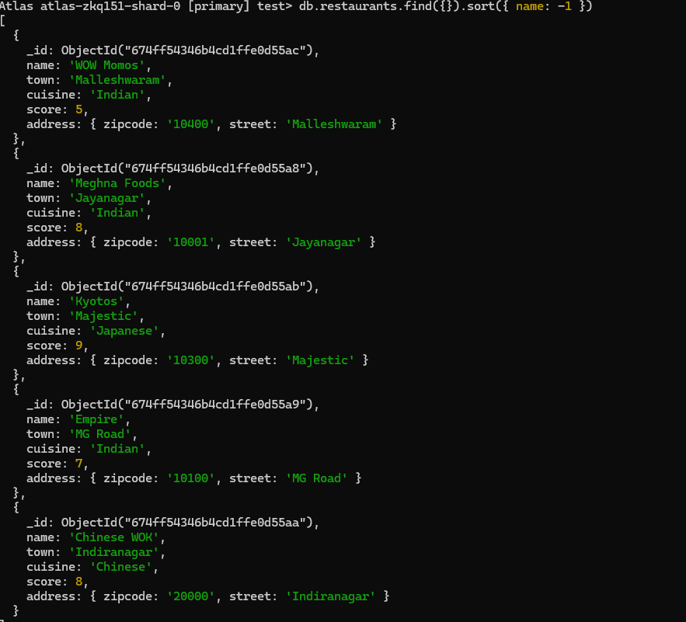

**4.Write a MongoDB query to find the restaurant Id, name, town and cuisine for those restaurants which achieved a score which is not more than 10.**

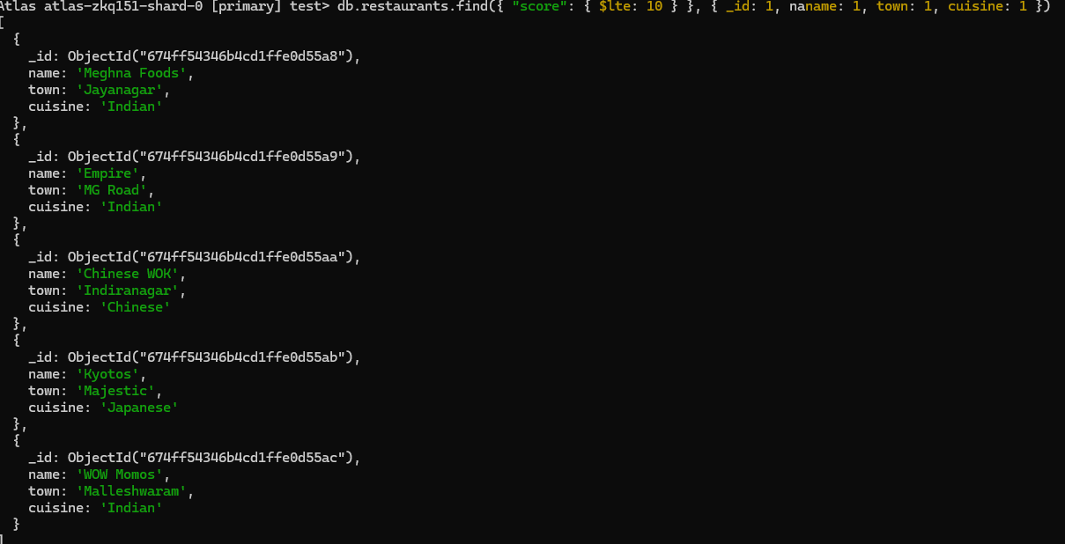

**5.Write a MongoDB query to find the average score for each restaurant.**

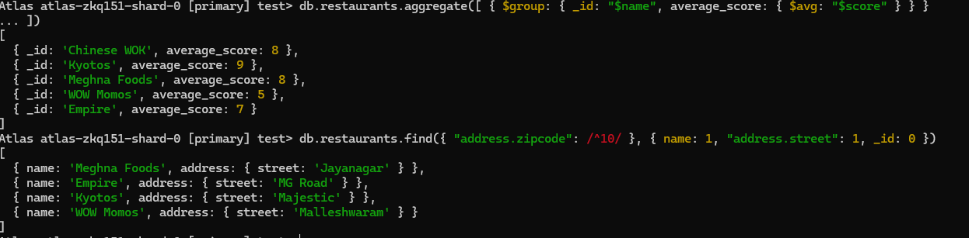

**6.Write a MongoDB query to find the name and address of the restaurants that have a zipcode that starts with '10'.**



